Menu Navigation
Home

How It Works
Water from Air
Water Quality

Products
HydroCell™ STANDUP
Filter Replacement Kits

Resources
Customer Testimonials
Help Center
Financing
Warranty
Blog

Case Studies
Lab Report

Contact

FOOTER:

Privacy Policy
Terms & Conditions
Case Studies: https://watergen.com/case-studies/

Lab Report: https://www.spoutwater.com/pages/testing

Layout/Design Inspo
HERO Section

Home Page

SECTION 1 — HERO
SPAN: Atmospheric Water Machine
H1: Air to Water Generators: Generate Water From the Air in Your
Home
Office
Kitchen
Shop
Cabin
Factory
Break Room
PARAGRAPH: No plumbing. No plastic bottles. No problem.
Up to 5.5 gallons a day from the air*
Primary CTA Button: Order Air to Water Generator
Secondary Button: Talk to an Expert
Tertiary Button: Read the Lab Report
$1,495 PRICE · $800 OFF · SHIPS IMMEDIATELY
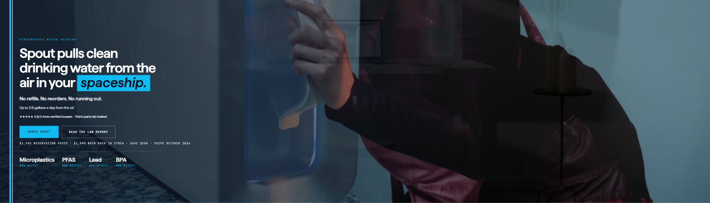

CAROUSEL SLIDER:



SECTION 2 — HOW IT WORKS
SPAN: How It Works
H2: Air In. Water OUT.
Four (4) Boxes:
H3: 01. Air Enters the System
The system pulls in outside air and filters out dust and other particles before collecting moisture.
H3: 02. Moisture Is Condensed
The system cools humid air until the moisture turns into liquid water that can be collected.
H3: 03. Water Is Treated
The collected water goes through filtration and treatment processes designed to improve its quality.
H3: 04. Water Is Stored or Dispensed
The treated water is stored in a tank, dispensed for use, or connected to another water system.
The EPA's assessment of AWGs documents systems using combinations of air filtration, condensation, storage, carbon filtration, sediment filtration, UV treatment, mineralization, and other treatment methods.
CTA Button: Explore the Technology
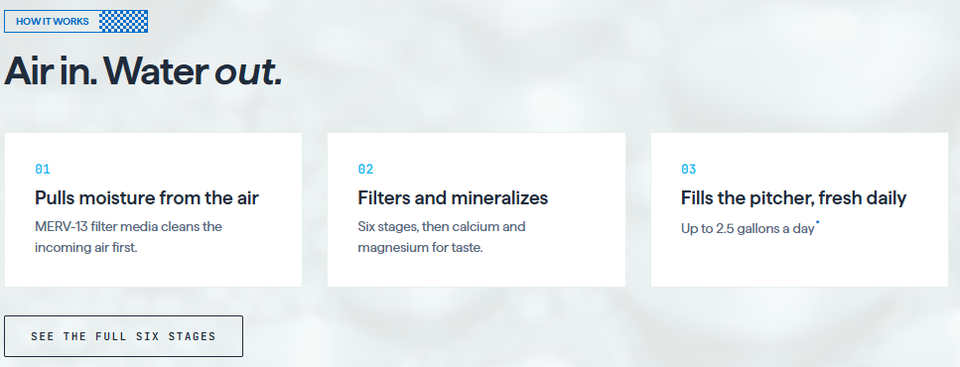

SECTION 3 — WHAT IS AN ATMOSPHERIC WATER GENERATOR?
H2: What Is an Atmospheric Water Generator?
An atmospheric water generator, or AWG, is a system designed to extract water vapor from ambient air and convert it into liquid water. Many systems accomplish this by drawing air into the machine, filtering the incoming air, cooling it to the dew point, collecting condensation, and then treating the collected water through additional filtration or purification processes.
Instead of transporting water from a distant source, atmospheric water generation moves part of the water-production process closer to the place where the water will actually be used.
The technology can range from compact systems designed for drinking water to larger systems capable of supporting commercial, industrial, institutional, and community applications.
EPA research describes condensation-based atmospheric water generation as a technology that pulls moisture from surrounding air, while noting that production depends heavily on available water vapor and temperature.
CTA: Learn How Water From Air Works

SECTION 4 — WHERE AIR TO WATER GENERATORS FIT
SPAN: Where Air to Water Generators Fit
H2: Built for the home first.
Atmospheric water generators offer a new approach to water production by capturing moisture already present in the air. Air to Water Generators helps homes, businesses, organizations, and communities explore scalable water-from-air systems designed to produce water where it is needed.
From individual drinking-water applications to larger commercial and industrial systems, atmospheric water generation can provide an additional source of water without relying exclusively on traditional wells, pipelines, bottled water, or water delivery.
Four (4) Text Boxes:
Residential • Commercial • Emergency • Off-Grid
Box 1:
For Daily Living
Water for the Home
Use it for drinking, meals, coffee, and other everyday needs without relying on bottled water.
Box 2:
For the Workplace
Water for Offices
Provide convenient on-site water while reducing the need for bottled deliveries and disposable containers.
Box 3:
For Added Security
Backup Water Supply
Maintain access to another water source during service interruptions, emergencies, or unexpected disruptions.
Box 4:
For Remote Locations
Water Beyond the Water Line
Produce water in RVs, remote properties, job sites, and other locations where electricity is available.
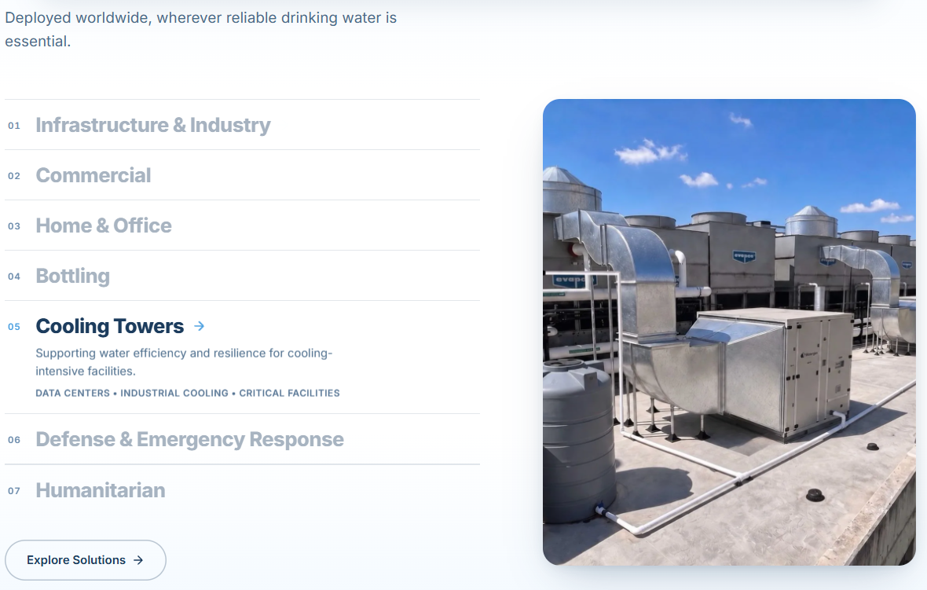

SECTION 5 — WHY ATMOSPHERIC WATER GENERATION?
H2: Why Atmospheric Water Generation?
H3: A Different Way to Think About Where Water Comes From
Most water systems begin with a remote source. Water may travel through wells, treatment plants, pipelines, trucks, bottles, storage tanks, or distribution infrastructure before reaching the people who use it.
Atmospheric water generation introduces another possibility: produce water closer to the point of use by utilizing moisture already present in the surrounding air.
Three (3) Boxes:
H3: Produce Water On-Site
Reduce dependence on transporting every gallon of water from somewhere else.
H3: Build Water Resilience
Add another potential water source where interruptions, shortages, infrastructure limitations, or remote locations make water availability more difficult.
H3: Reduce Bottled Water Dependence
For appropriate applications, on-site generation may help decrease dependence on recurring bottled-water purchases and deliveries.
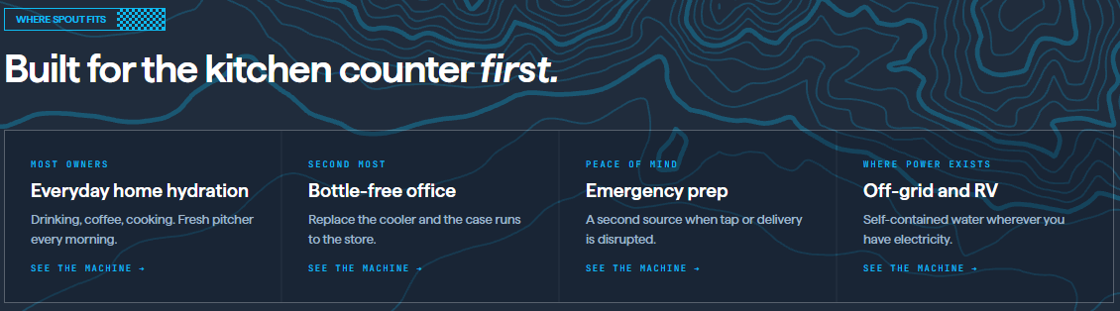

SECTION 5 — DO THE MATH
SPAN: Compare Water Costs
H2: Do The Math
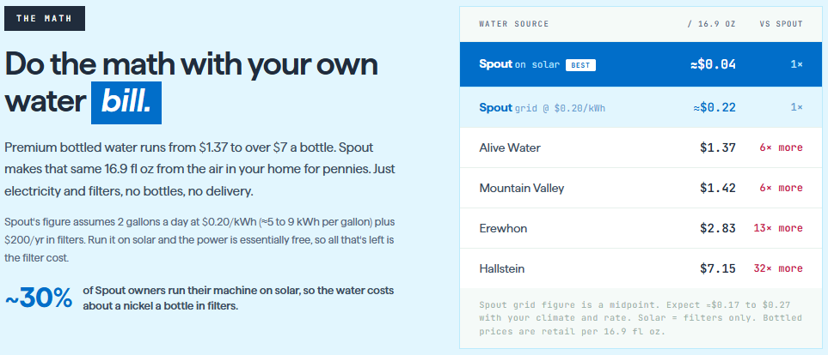

SECTION 6 — AN HONEST COMPARISON
SPAN: Compare and See What’s Best For You
H2: An Honest Comparison
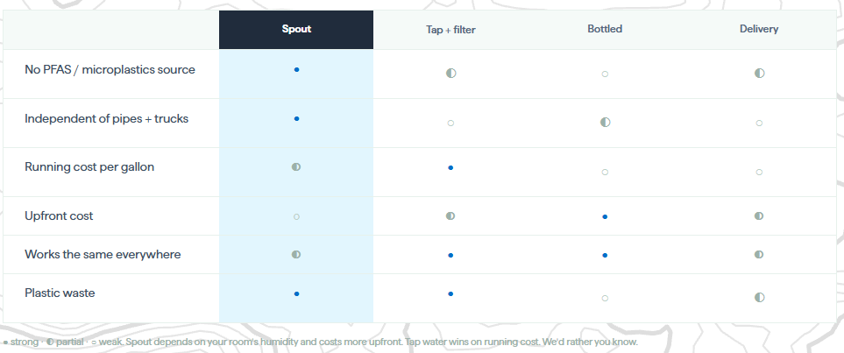

SECTION 6 — FREQUENTLY ASKED QUESTIONS
FAQ: Quick Answers
H2: Frequently Asked Questions
H3: How much water will I get?
Up to 5.5 gal/day depending on your climate. Most owners pour 1 to 3 pitchers.

H3: How loud is it?
You'll hear it in the room, not the next room. Many owners run it overnight.

H3: What does it cost to run?
≈5 to 9 kWh per gallon plus filters. Your rate sets the price; see the math above.

H3: Does it heat the room?
It vents warm air like a large dehumidifier. Summer: run overnight. Winter: free heat.

H3: What are the filters?
Two, swapped every 3 months, under 2 minutes, no tools. $99 per 6-month box.

H3: What if it breaks?
1-year warranty, real phone support: (213) 335-2121. Terms on the product page.

H3: Can I return it?
30-day money-back guarantee from the day it arrives.

H3: What does it taste like?
Alkaline, mineralized. 93% of surveyed owners rate the taste good or excellent.\

SECTION 7 — CALL TO ACTION
H2: Order an Air to Water Generator
$1,495 price, $500 below the $1,995 in-stock price · Ships Immediately · 1-Year Warranty

CTA Button: Order Now

How It Works

Water From Air

SECTION 1 — HERO
H1: How It Works
SPAN: Atmospheric Water Machine
H2: From Air to Water.
PARAGRAPH: Air to Water Generators pull moisture from the air, turn it into water, then filter and treat it for everyday use. The result is a fresh water source produced right where you need it—without bottles, deliveries, or a traditional water line.
Up to 5.5 gallons a day from the air*
Primary CTA Button: Order Air to Water Generator
Secondary Button: Talk to an Expert
Tertiary Button: Read the Lab Report
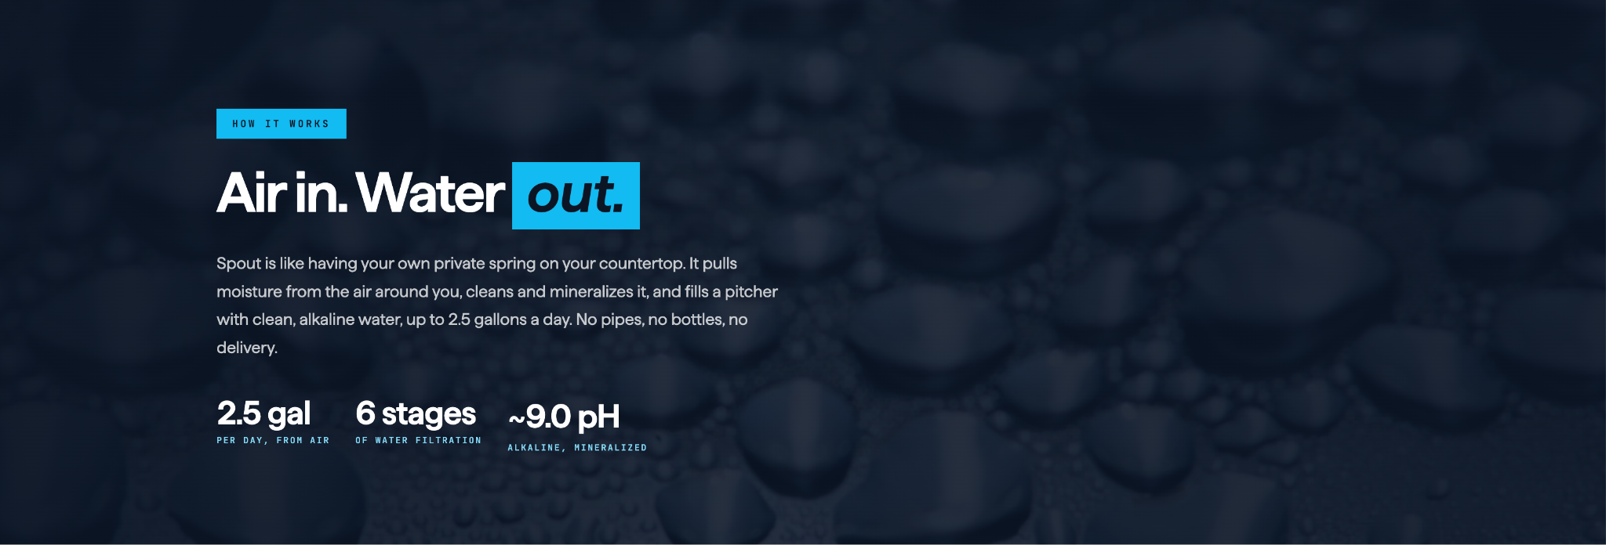

SECTION 2 — HOW IT WORKS
SPAN: How It Works
H2: Air In. Water OUT.
Four (4) Boxes:
H3: 01. Air Enters the System
The system pulls in outside air and filters out dust and other particles before collecting moisture.
H3: 02. Moisture Is Condensed
The system cools humid air until the moisture turns into liquid water that can be collected.
H3: 03. Water Is Treated
The collected water goes through filtration and treatment processes designed to improve its quality.
H3: 04. Water Is Stored or Dispensed
The treated water is stored in a tank, dispensed for use, or connected to another water system.
The EPA's assessment of AWGs documents systems using combinations of air filtration, condensation, storage, carbon filtration, sediment filtration, UV treatment, mineralization, and other treatment methods.
CTA Button: Explore the Technology
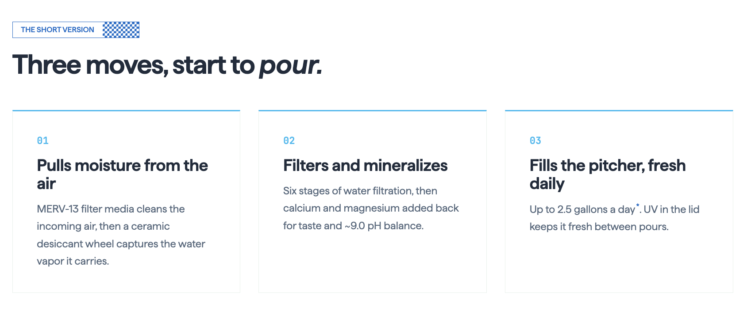

SECTION 4 — FROM AIR TO GLASS
SPAN: Eight stages between air to glass.
H2: From Air To Glass: The Purification Process
01 Air Filter – traps dust and particulates
02 Softening Filter – removes calcium/magnesium (anti-scale)
03 Sediment Filter – removes particles >5 microns
04 Ultrafiltration Membrane – blocks particles <0.01 micron
05 Pre-Carbon Filter – removes chlorine, pesticides, VOCs
06 Electropositive Membrane – filters viruses, bacteria, trace pharmaceuticals
07 LED-UV (Lower Tank) – sterilizes bacteria & microorganisms
08 LED-UV (Upper Tank) – final purification layer

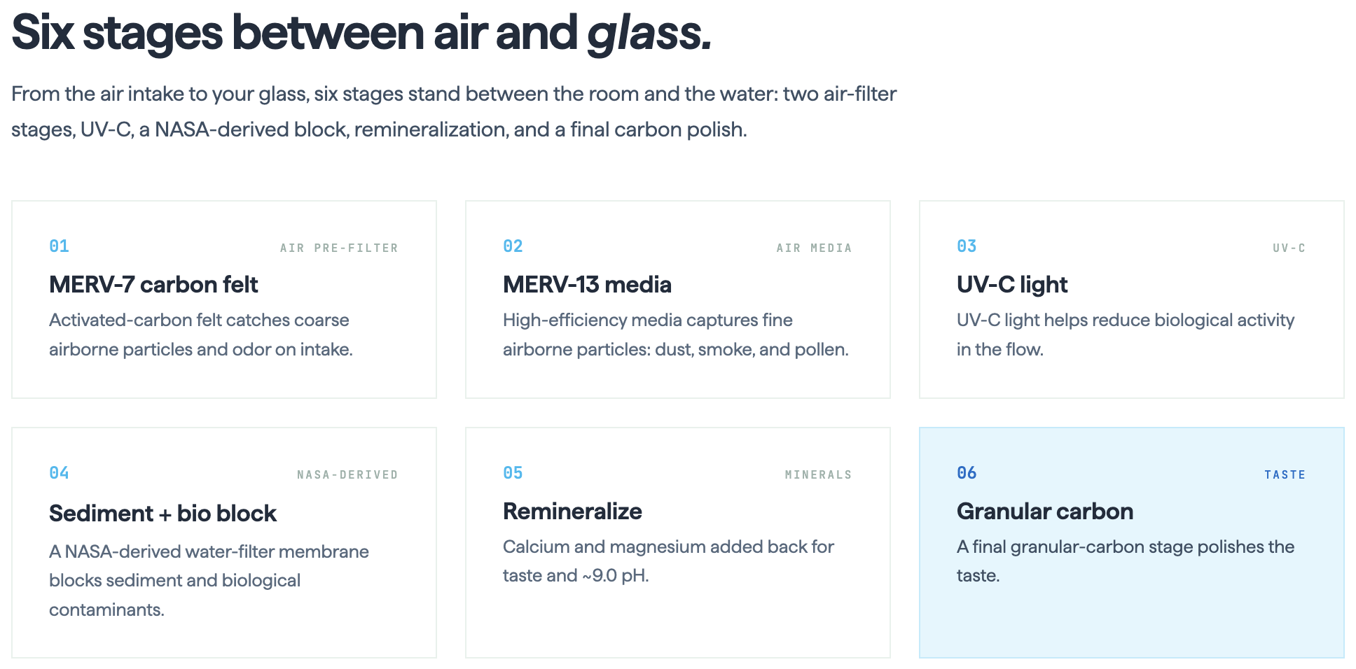

SECTION 5 — HOW MUCH WATER
SPAN: How Much Water You'll Get
H2: Warmer, more humid air can produce more water.
Water output depends on the temperature and humidity of the surrounding air. In warmer, more humid conditions, Air to Water Generators can capture more moisture and produce more water each day. For exact output ranges, view the production chart for your specific system.
Button: See the Production Grid | Button: See The Lab Report
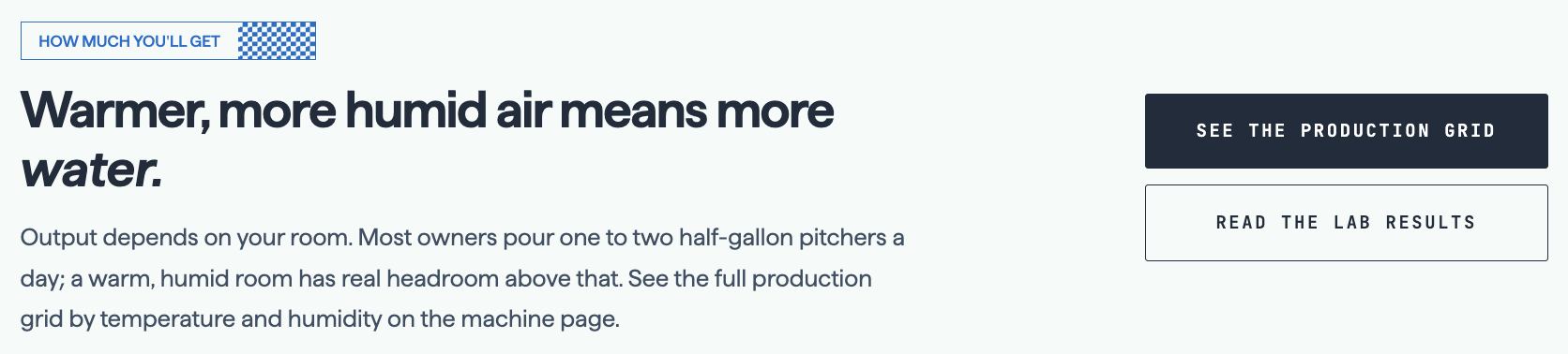

SECTION 6 — CTA SECTION
H2: From the air to clean, crisp water in your
Home
Office
Kitchen
Shop
Cabin
Factory
Break Room
Button: Order Today | Button: Talk to An Expert


Water Quality

SECTION 1 — WATER QUALITY
H1: Water Quality
H2: Tap Water Isn’t What It Used To Be
H3: From aging infrastructure and PFAS concerns to contaminated wells and boil water notices, water quality challenges affect communities across the United States.².
PARAGRAPH: Water contamination insights are based on verified national datasets from the U.S. Environmental Protection Agency (EPA), U.S. Geological Survey (USGS), Environmental Working Group (EWG), and other state and federal water-quality sources. These datasets help identify risks such as PFAS contamination, agricultural runoff, lead service lines, groundwater concerns, and boil water notices to assess water quality and infrastructure vulnerability across the United States.
Primary CTA Button: How It Works
Secondary CTA Button: See the Product
Tertiary CTA Button: Talk to an Expert
PICTURE OF CONTAMINATION MAP (ewg.org, drought.gov, )

SECTION 2 — WATER AT A GLANCE
SPAN: What’s In The Water?
H2: What Texas Water Looks Like
PARAGRAPH: Texas communities face growing water quality challenges. Aging pipes, industrial activity, and naturally occurring contaminants have increased concerns about boil notices, PFAS, and the overall safety of tap water.
TAB SECTION:

H3: PFAS (Forever Chemicals)
Why it matters: PFAS exposure has been associated with potential health risks, including effects on the immune and reproductive systems and certain cancers.
Where it’s found: PFAS has been identified in municipal water supplies and underground water sources across Texas, meaning both public water customers and private well users may be affected.
¹ PFAS, commonly called “forever chemicals,” are long-lasting industrial compounds that have been detected in public water systems and groundwater throughout Texas. The 2025 Water Stress Index by Salford & Co. identified confirmed areas of concern in more than 30 Texas counties as of 2024.

H3: Arsenic
Why it matters: Long-term exposure to elevated arsenic levels can increase the risk of certain cancers and other serious health effects.
Where it’s found: Arsenic occurs naturally in groundwater and is more commonly found at elevated levels in parts of Central and West Texas.
² Arsenic is a naturally occurring contaminant in Texas groundwater. Some wells, particularly in West Texas, have recorded levels above the EPA drinking water standard of 10 µg/L. Sources: U.S. Environmental Protection Agency (EPA) and U.S. Geological Survey (USGS).

H3: Nitrates
Why it matters: Elevated nitrate levels can pose serious health risks, particularly for infants and pregnant women.
Where it’s found: Higher nitrate concentrations are more common in rural and agricultural areas where fertilizers and animal waste can affect groundwater.
³ Nitrate contamination in rural Texas is often associated with agricultural runoff, fertilizer use, and livestock operations. According to the 2025 Water Stress Index by Salford & Co., agricultural activity represented 24% of active groundwater contamination cases in the state.

H3: Microplastics
Why it matters: Researchers are still studying the long-term health effects of microplastic exposure, including possible impacts on inflammation and hormone function.
Where it’s found: Microplastics have been detected in treated drinking water and may enter water supplies through environmental pollution, aging infrastructure, and other sources.
⁴ Microplastics are plastic particles smaller than 5 mm that have been found in drinking water systems in the United States and around the world. Research into their potential effects on human health is ongoing. Source: U.S. Environmental Protection Agency (EPA).

SECTION 3 — FAQs
H2: Frequently Asked Questions
H3: Do I need to add my own filter or treatment?
The water from Aquaria Hydropack series or Hydropixel is filtered as part of the generation process and exceeds EPA standards straight from the system — no additional filter or treatment required. If you'd like ongoing peace of mind, we recommend a simple annual third-party water test on your installation to confirm performance over time.
H3: How does Aquaria water compare to tap or bottled water?
Tap water quality depends on your local source and infrastructure, and can carry PFAS, arsenic, nitrates, or microplastics; bottled water adds ongoing cost and plastic waste. Aquaria water is made on-site from air and tested non-detect for those same contaminants, so you get consistent, verified quality without a monthly delivery or an uncertain source. It also comes out at a balanced pH of 6.5–8.5.
H3: Who tests the water, and can I see the results?
All of our water testing is performed by SimpleLab, an award-winning, independent, ISO-accredited laboratory that specializes in drinking water. We publish the full results — six downloadable lab reports covering PFAS, microplastics, and overall water quality for both the Hydropack series and Hydropixel — right on this page. We recommend reviewing them, and once your system is installed we suggest a simple annual third-party test to confirm performance over time.
H3: What contaminants does the water test free of?
In an independent lab testing by SimpleLab, Aquaria water came back "Not Detected" for all four contaminants we test for: PFAS ("forever chemicals"), arsenic, nitrates, and microplastics. For comparison, typical Texas utility water in the same tests showed measurable PFAS (around 0.025 PPB), arsenic (around 0.0075 PPM), and nitrates (around 0.73 PPM). Because the water is generated from air rather than drawn from the ground or a municipal line, it doesn't start with the contaminants those sources can carry.
H3: Is the water safe to drink?
Yes. Every drop passes through multi-stage filtration, and in independent lab testing by Microbac Laboratories, Pace Analytical, and EMSL Analytical, Aquaria's water was non-detect for 100+ contaminants, no microplastics, PFAS, or dissolved heavy metals. We recommend an annual third-party water test on your own installation to confirm performance over time.

Products

HydroCell™ STANDUP

SECTION 1 — HydroCell™ Standup
H1: HydroCell™ Standup
H2: Pure Drinking Water Straight from the Air
PARAGRAPH: A convenient indoor water source for homes, offices, and event spaces. No heavy jugs or scheduled deliveries—just fresh drinking water produced when you need it. Set it up, switch it on, and start making water from the air.
$1,495.00 $1,995.00
Primary Button: Buy Now
Secondary Button: Full Specifications
Tertiary Button: Talk to an Expert
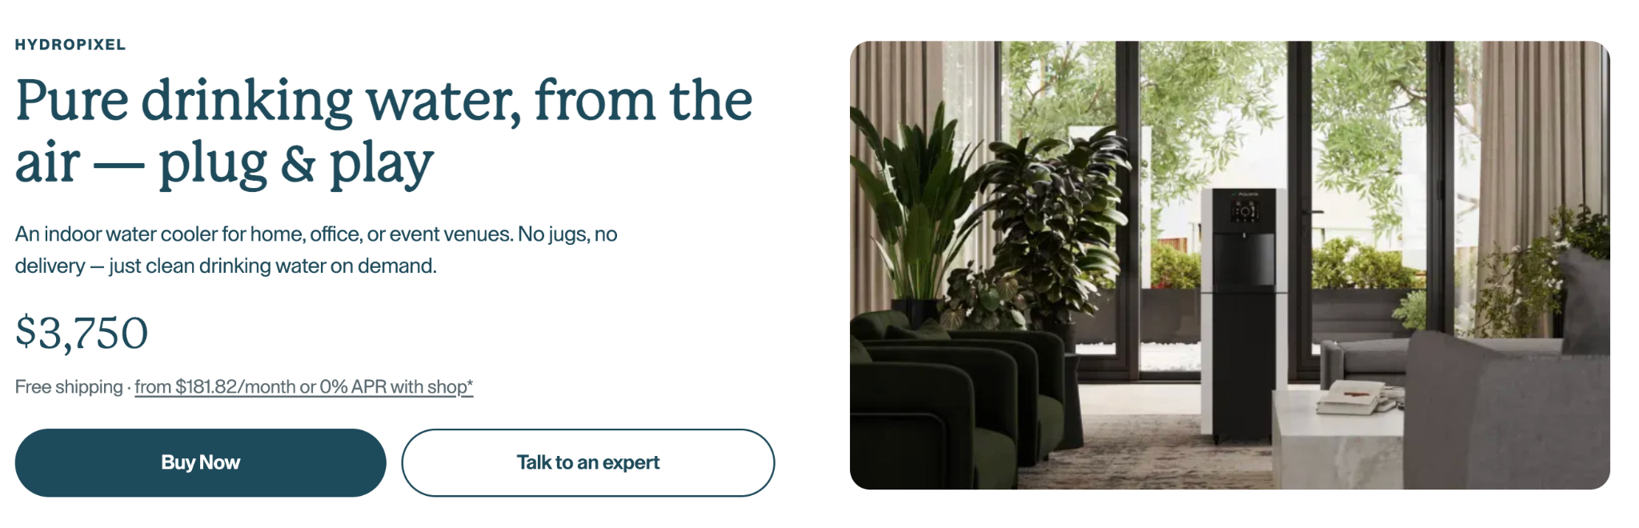

SECTION 2 — HydroCell™ Standup
H2: Why Buy a HydroCell?
PARAGRAPH: Tap water can be unreliable and bottled water creates waste — HydroCell gives you clean water, on your terms.
3 Boxes:
Health:
Delivers contaminant-free water (PFAS, lead, microplastics).
Independence:
Works anywhere — no plumbing or bottles required.
Impact:
Replaces 14,000 bottles/year; cuts 1.2 tons CO₂/year; costs just $0.06/L.
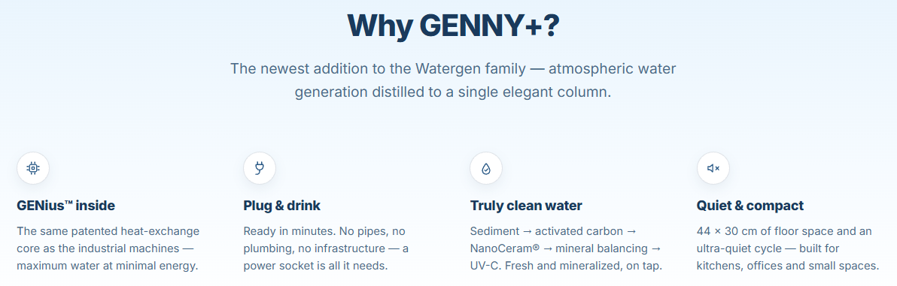
IMAGE CAROUSEL SECTION:
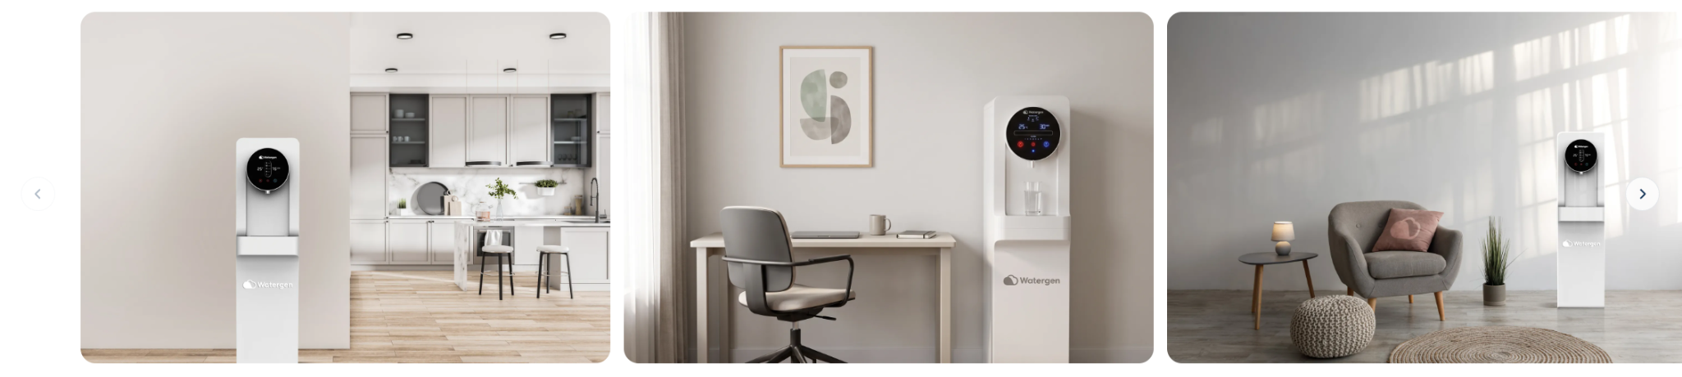

SECTION 3 — Specifications
H2: Specifications
Water Generation: Up to 20 L / 5.28 gal a day (@ 30°C / 86°F), 80% RH)
Internal Water Storage: 19L, (upper, hot, cold tanks combined)
Weight: 105 lbs
Dimensions: 14.8 × 12.1 × 45.4 in
Hot Water: 43°F / 6°C
Cold Water: 185°F / 85°C
Climate Conditions: From 59–113°F / 15–45°C and 30-99% RH
Energy Per Liter:
Power:
Power Consumption:
Air Filtration:
Water Purification:

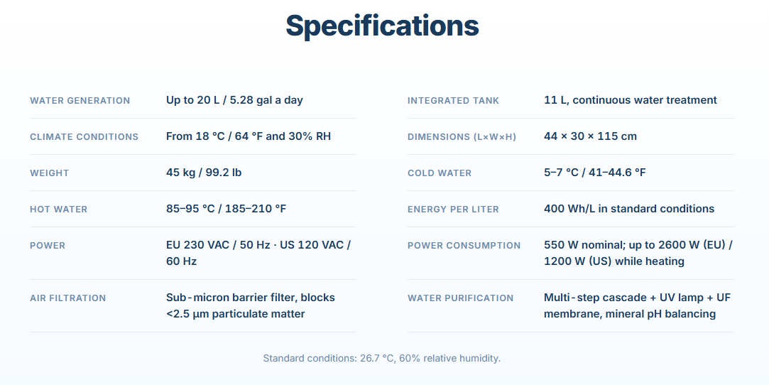

SECTION 6 — PRODUCT CATEGORIES
H2: The Right Atmospheric Water Generator for the Right Situation
Rather than starting with a model number, help visitors start with how much water they need and where they need it. Watergen and Aquaria both use scale/application segmentation effectively.
H3: Residential Air to Water Generators
homes, drinking water, kitchens, secondary water supply, rural properties, and off-grid living.
H3: Commercial Air to Water Generators
offices, hospitality properties, campuses, workplaces, retail environments, and commercial facilities.
H3: Industrial Air to Water Generators
industrial sites, infrastructure, manufacturing, energy, remote facilities, and other demanding environments.
H3: Mobile & Emergency Water Systems
Emergency response, mobile systems

Filter Replacement Kits

SECTION 1 — HydroCell™ Filter Replacements
H1: HydroCell™ Filter Replacement Kits
H2: The filtration system does the work. Routine maintenance keeps it going.
PARAGRAPH: HydroCell™ Replacement Filter Kits are pre-bundled maintenance packs designed to keep your unit’s purification system performing consistently over time.
$100
Primary Button: Buy Now
Tertiary Button: Talk to an Expert
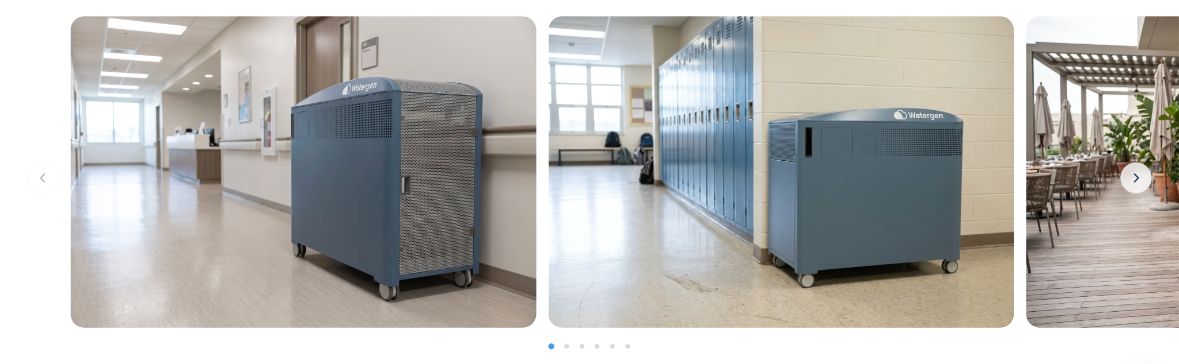
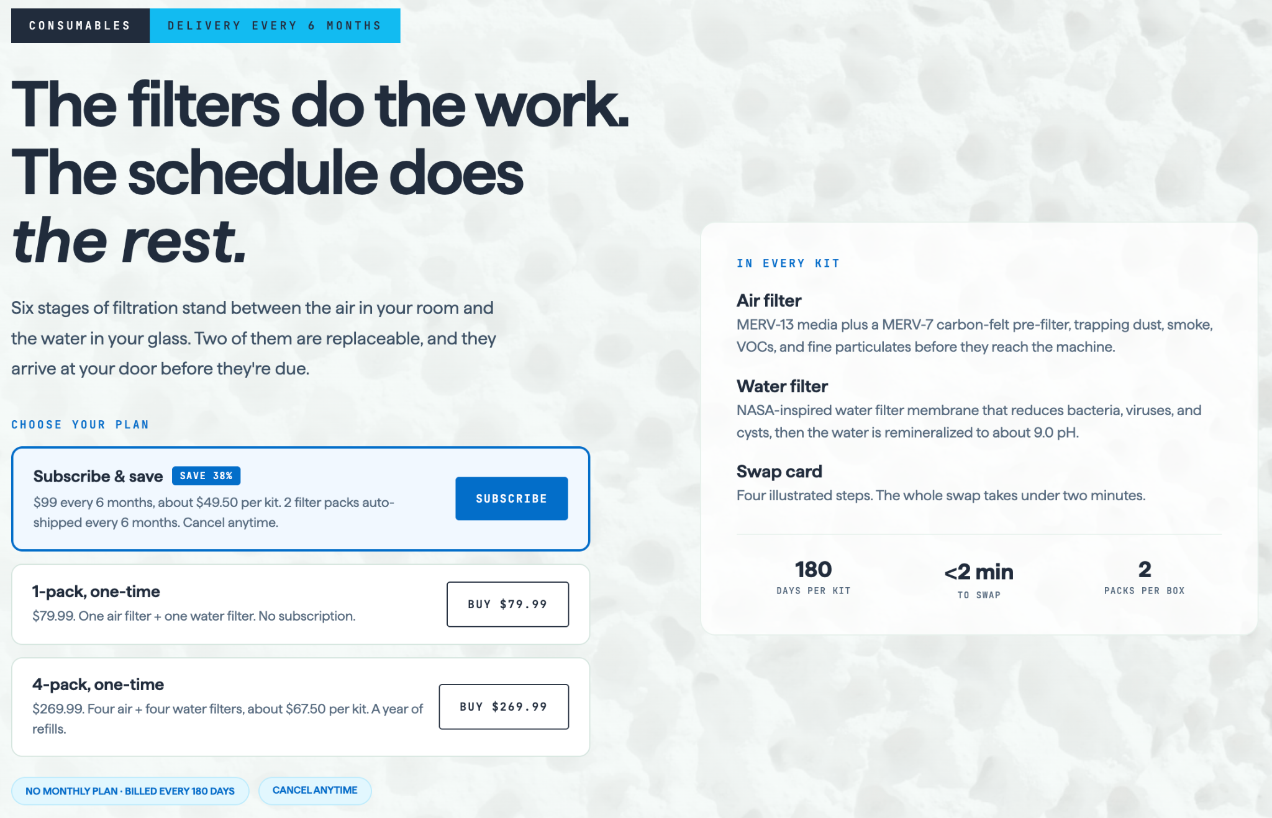
H2: The Refill Kit
PARAGRAPH: Here’s what’s included in each kit.

Month 6: Standard Refresh
Softening filter
Sediment filter
Carbon filter
Electropositive membrane filter

Month 12: Standard Refresh + Ultra-Fine Membrane
Softening filter
Sediment filter
Carbon filter
Ultra-fine membrane filter
Electropositive membrane filter

Month 18: Standard Refresh + UV Lamps
Softening filter
Sediment filter
Carbon filter
Bottom tank LED-UV lamp
Top tank LED-UV lamp
Electropositive membrane filter

Month 24: Standard Refresh + Ultra-Fine Membrane (repeat)
Softening filter
Sediment filter
Carbon filter
Ultra-fine membrane filter
Electropositive membrane filter

After Month 24, the cycle repeats with the same 6-month milestones to keep purification performance co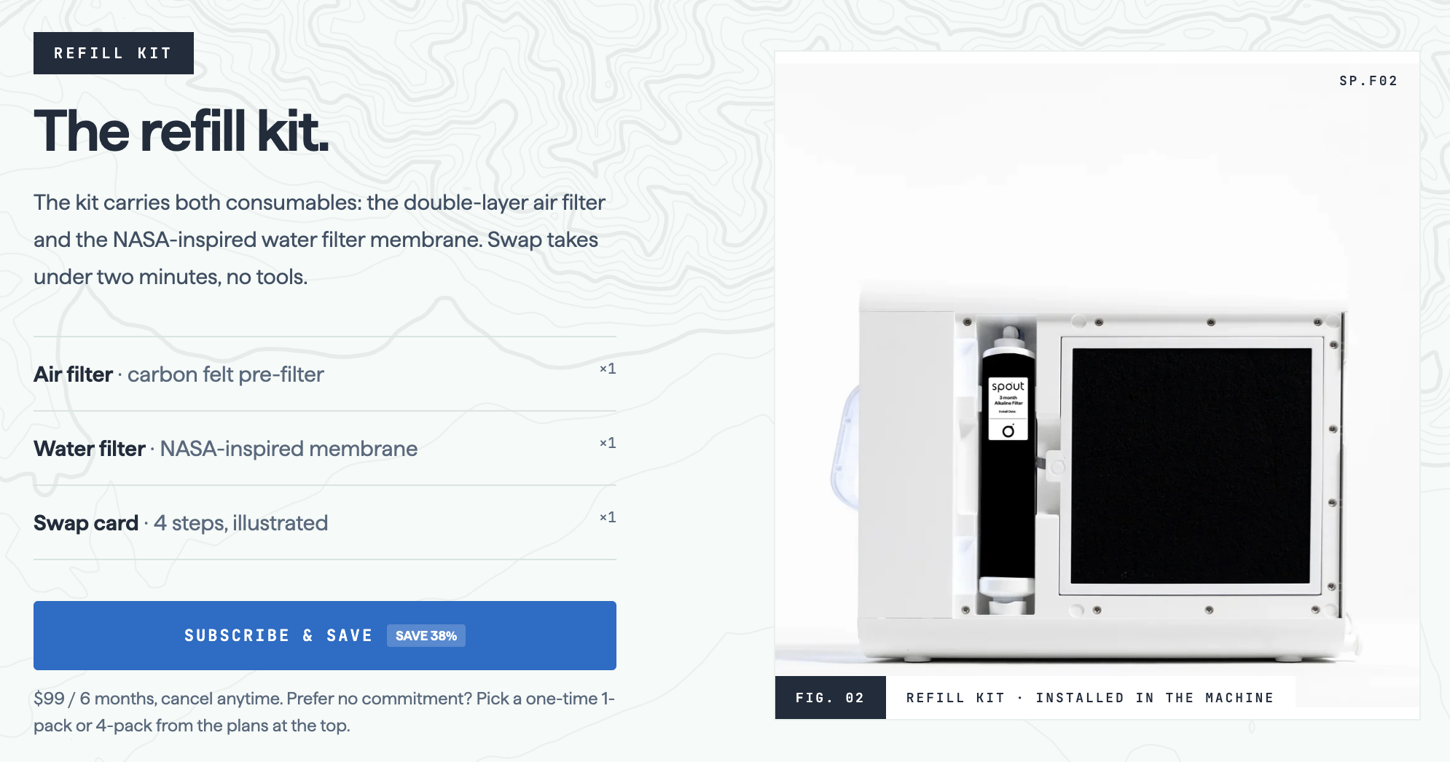nsistent over time.

Lab Report

SECTION 1 — The Lab Report
H1: The Lab Report
H2: What the Lab Reports Say
PARAGRAPH: In the HydroCell™ water samples tested, independent labs found these not detected.
"Not detected" means the analyte was below the laboratory's reporting limit in that tested sample. Reporting limits and methods are shown on each report.

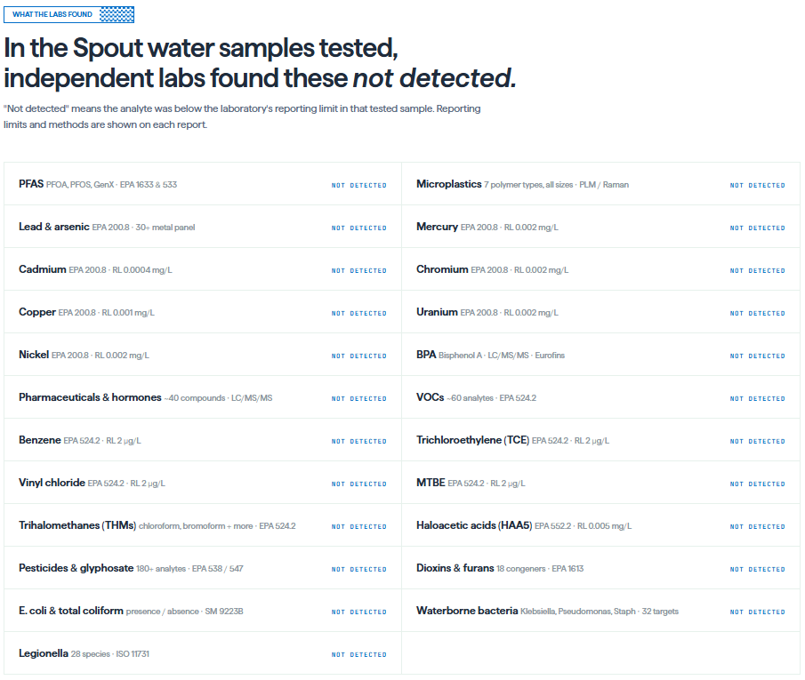

SECTION 2 — The Water Itself
H2: What the Water Itself Is Like
PARAGRAPH: Clean, soft, lightly alkaline.
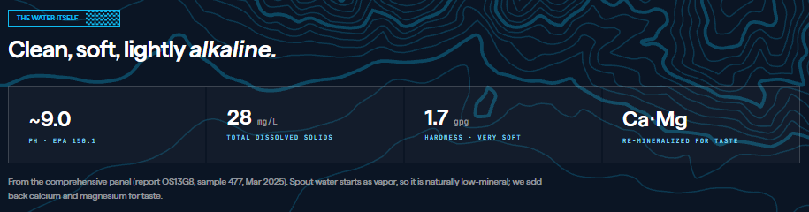

Bottom Section (Middle Aligned):

A Note About These Results

These findings reflect individual water samples tested under specific conditions and should not be considered a guarantee of identical results at all times. Water quality can vary based on your environment, filter condition, and routine maintenance. We conduct ongoing testing through accredited independent laboratories and make the complete reports available for transparency.

Have a question about a test result? Contact us →

Contact
H1: Contact

H2: Talk to An Expert

PARAGRAPH: Whether you are exploring atmospheric water generation for your home, business, facility, or remote operation, our team is here to help you understand your options. Complete the form below and a member of our team will follow up with you.



H2: Contact Information:

Headquarters

Air to Water Generators
Houston, TX, USA

Phone
+1 (123) 456-7890
Email
contactus@watergen.com
Follow Us

LinkedIn: https://www.linkedin.com/company/water-generators/
Facebook: https://www.facebook.com/a2watergenerators
Instagram: https://www.instagram.com/watergenerators
YouTube:
TikTok: https://www.tiktok.com/@watergenerators
Google Business Profile: https://share.google/vD7mnrJa1jZeTicZO


EXTRA
SECTION 5 — PRODUCT CATEGORIES
Small label:
Water Solutions at Every Scale
H2: Find the Right Atmospheric Water Generator
Rather than starting with a model number, help visitors start with how much water they need and where they need it. Watergen and Aquaria both use scale/application segmentation effectively.
H3: Residential Air to Water Generators
Explore atmospheric water generation for homes, drinking water, kitchens, secondary water supply, rural properties, and off-grid living.
CTA: Residential Systems
H3: Commercial Air to Water Generators
Generate water on-site for offices, hospitality properties, campuses, workplaces, retail environments, and commercial facilities.
CTA: Commercial Systems
H3: Industrial Air to Water Generators
Explore higher-capacity atmospheric water generation for industrial sites, infrastructure, manufacturing, energy, remote facilities, and other demanding environments.
CTA: Industrial Systems
H3: Mobile & Emergency Water Systems
Deploy atmospheric water generation where water infrastructure is unavailable, compromised, difficult to access, or temporarily interrupted.
CTA: Emergency & Mobile Systems
Image Prompt — Product Category Background
Four-panel premium editorial photography composition, each panel depicting a different atmospheric water generation application: elegant modern residence, contemporary corporate office, industrial facility, and remote emergency response environment, consistent natural lighting and architectural quality across all four scenes, atmospheric water generator visible but integrated naturally into each setting, bright clean environmental technology aesthetic, blue-gray equipment with subtle #43A5FF accents, no brands, no text, realistic proportions, white and sky blue palette, 16:9

SECTION 6 — PRODUCT SELECTOR / LEAD GENERATION
H2: How Much Water Do You Need?
The best atmospheric water generator depends on more than the size of the machine.
The amount of water a system can produce may vary with temperature, relative humidity, operating conditions, system capacity, energy availability, and intended use. EPA research specifically notes that AWG water-production rates depend heavily on temperature and atmospheric water vapor.
Answer a few questions and we can help identify the type of system that best fits your application.
H3: Where Will the System Operate?
Home, business, industrial facility, remote property, emergency site, or another environment.
H3: How Much Water Do You Need?
Estimate your expected daily demand so the system can be sized appropriately.
H3: What Are the Local Conditions?
Temperature and humidity influence atmospheric water production.
H3: How Will the Water Be Used?
Drinking, facility operations, storage, backup supply, or another application.
CTA: Find My Water Solution
Image Prompt
Top-down premium photograph of a clear glass of water centered on an architectural planning table alongside subtle environmental data elements represented physically through a thermometer, hygrometer, facility blueprint, and small scale water tank model, extremely clean modern composition, white table, soft daylight, pale blue shadowing, restrained #43A5FF accents, sophisticated engineering consultancy aesthetic, no visible words, no screens, no logos, realistic photography, 4:3

SECTION 7 — WATER QUALITY
This deserves major prominence. It is one of the first questions someone will ask an AI assistant about the technology.
Small label:
Water Quality
H2: Water Generation Is Only Part of the Process
Producing condensation and producing water intended for human consumption are not the same thing.
An atmospheric water system must be evaluated as a complete system—from incoming air and condensation to treatment, storage, maintenance, and dispensing. Depending on the equipment, water-treatment processes may incorporate technologies such as sediment filtration, activated carbon, UV treatment, mineralization, or other purification stages.
Water quality claims should always be tied to the specific equipment, test data, certifications, operating requirements, and intended use of the system.
The EPA has specifically studied microbial water quality in atmospheric water generation systems and emphasizes the importance of treatment and management after condensation.
CTA: Learn About Water Quality
Image Prompt
Ultra-clean photorealistic water quality laboratory scene, crystal-clear water sample in transparent laboratory glassware, scientist's gloved hands conducting non-branded water testing in the background, subtle filtration equipment visible out of focus, luminous white environment with #D9F1FC sky blue reflections and #43A5FF accents, premium clinical but welcoming aesthetic, natural depth of field, scientifically credible, no text, no logos, no dramatic neon, horizontal 3:2
This is an important E-E-A-T section. Eventually include real lab reports, certifications, technical sheets, and testing documentation here.

SECTION 8 — CONDITIONS / TRANSPARENCY
This is one thing I would borrow conceptually from Spout: tell people when the technology performs differently rather than pretending it works identically everywhere. Spout openly states that its output changes with climate conditions.
H2: How Climate Affects Water Production
Water exists in the atmosphere as invisible water vapor. Atmospheric water generators capture some of that moisture, which means local environmental conditions matter.
H3: Relative Humidity
More available atmospheric moisture generally provides more water vapor for the system to capture.
H3: Temperature
Temperature affects the condensation process and can influence both water production and system efficiency.
H3: System Capacity
Different atmospheric water generators are engineered for different output ranges and applications.
H3: Operating Environment
Indoor and outdoor conditions, airflow, electrical supply, installation, and operating hours can also affect performance.
CTA: See if Atmospheric Water Generation Fits Your Location
Image Prompt
Photorealistic panoramic environmental transition from dry inland climate on the left through temperate conditions into humid coastal conditions on the right, same sophisticated atmospheric water generation system subtly placed within each environment to demonstrate changing climate conditions, physically realistic sky and vegetation, no exaggerated desert, elegant visual gradient, air moisture becoming slightly more visible through natural haze toward humid side, pale blue and off-white color grade, premium scientific editorial photography, no text, no logos, wide 21:9

SECTION 9 — APPLICATIONS
Small label:
Where Water From Air Can Work
H2: Atmospheric Water Generation for Real-World Applications
Build each into an internal landing page over time.
H3: Homes & Residential Properties
An additional approach to water production for homes, rural properties, second homes, and off-grid living.
H3: Businesses & Offices
On-site drinking-water generation for workplaces and commercial environments.
H3: Hotels & Hospitality
Explore alternatives to transporting and storing bottled drinking water for guests and staff.
H3: Industrial Facilities
Scalable water-production options for facilities where access, infrastructure, or resilience matters.
H3: Agriculture & Remote Operations
Consider atmospheric water generation where traditional water infrastructure may be difficult or expensive to extend.
H3: Emergency Preparedness
Add another potential source of water production when conventional supply infrastructure is disrupted.
H3: Communities & Infrastructure
Explore distributed atmospheric water systems as part of broader water-resilience strategies.
H3: Off-Grid Applications
Combine appropriate atmospheric water technology with independent infrastructure for remote environments.
Image Prompt
Photorealistic premium documentary-style scene showing an atmospheric water generator operating at a modern remote facility in a wide open landscape, workers in the far background but technology and environment are primary subjects, system connected to a clean water storage tank, subtle solar array nearby without implying solar is required, bright morning air, natural sky, clean engineered installation, color palette based on #43A5FF, #088AE3, #F8FCFD and #173B57, sophisticated infrastructure campaign photography, no text, no logos, 16:9

SECTION 11 — SUSTAINABILITY
H2: Produce Water Closer to Where It Is Used
Moving water requires infrastructure. Bottling, transporting, storing, and delivering water can also introduce packaging and logistics into the water supply chain.
Atmospheric water generation creates an opportunity to produce water at or near the point of use. Depending on the application and energy source, this can reduce reliance on recurring water transportation and disposable bottled-water systems.
The environmental impact of any installation should still be evaluated based on energy consumption, local climate, equipment efficiency, system lifespan, maintenance, and the water source it replaces.
Image Prompt
Premium conceptual sustainability photograph, clear reusable glass water vessel beside a modern atmospheric water generation unit in a bright architectural space, distant background subtly shows delivery trucks and stacks of disposable bottles fading out of relevance without appearing negative or dirty, foreground emphasizes local clean water production, natural sunlight, transparent materials, restrained coastal technology palette #43A5FF, #D9F1FC, #EFF9FD, #F8FCFD, no text, no logos, highly realistic commercial photography, 3:2

SECTION 12 — COMPANY / E-E-A-T
This is critical because Air to Water Generators is also effectively the exact name of the product category. Search engines need to understand that it is a company/entity, not just a generic page about generators.
Small label:
About Air to Water Generators
H2: Helping People Understand and Deploy Water-From-Air Technology
Air to Water Generators is focused on atmospheric water generation and the expanding role it can play in modern water infrastructure.
We help customers understand available technologies, evaluate applications, determine appropriate system capacity, and explore solutions for residential, commercial, industrial, emergency, and remote environments.
Our goal is simple: make atmospheric water generation easier to understand, compare, and implement.
CTA: About Air to Water Generators
H3: Education Before Equipment
The right solution starts with understanding water demand, environmental conditions, water-quality requirements, installation, operating costs, and system capabilities.
H3: Solutions Based on the Application
We evaluate the problem first and the equipment second.
H3: Water Expertise You Can Verify
Technical specifications, certifications, testing, documentation, and performance data should be accessible—not hidden behind marketing language.
Image Prompt
Photorealistic environmental engineering consultation, small diverse professional team reviewing atmospheric water generation equipment and water-demand plans at a bright modern facility, actual physical equipment in background rather than computer-generated interface, collaborative but sophisticated, natural expressions, crisp daylight, white architectural space with #43A5FF accents and dark #173B57 details, premium corporate editorial photography, no text, no logos, no lab coats unless contextually necessary, horizontal 3:2

SECTION 13 — PROOF / CASE STUDIES
Do not manufacture this section until there are legitimate deployments.
H2: Water From Air in the Real World
Atmospheric water generation is not just a laboratory concept. Systems are being deployed for residential, commercial, institutional, industrial, emergency, and remote applications around the world.
Explore Air to Water Generators projects to see the environment, system selection, water demand, operating conditions, and results behind each installation.
Future case-study format:
H3: The Challenge
What water problem existed?
H3: The Solution
What system was installed and why?
H3: The Environment
Temperature, humidity, location, application.
H3: The Results
Actual measured output, energy use, water quality, and performance.
CTA: View Projects
Watergen uses actual deployments and customer examples prominently, which is particularly valuable for this category because the technology itself still requires substantial buyer education.

SECTION 14 — LEARNING CENTER
Small label:
Atmospheric Water Generation Resources
H2: Learn About Water From Air
Short intro:
Atmospheric water generation combines principles from refrigeration, condensation, air treatment, water purification, water storage, energy management, and environmental science. Our Learning Center explains the technology in plain language so you can make informed decisions.
H3: What Is an Atmospheric Water Generator?
H3: How Does an Atmospheric Water Generator Work?
H3: How Much Water Can an Atmospheric Water Generator Produce?
H3: How Much Electricity Does an Atmospheric Water Generator Use?
H3: Do Air to Water Generators Work in Dry Climates?
H3: Is Water From Air Safe to Drink?
H3: Atmospheric Water Generator vs. Well Water
H3: Atmospheric Water Generator vs. Reverse Osmosis
H3: Atmospheric Water Generator Cost: What Determines the Price?
H3: Can Atmospheric Water Generators Run on Solar Power?
These should eventually become individual articles and be internally linked from the homepage.

SECTION 15 — FAQ
H2: Frequently Asked Questions About Air to Water Generators
H3: What is an atmospheric water generator?
An atmospheric water generator is a system that captures water vapor from ambient air and converts it into liquid water. Depending on the system and intended application, the collected water may then undergo additional filtration, purification, disinfection, mineralization, or storage.
H3: How does an air to water generator make water?
Most condensation-based systems draw humid air across a cooled surface. When the air reaches its dew point, water vapor condenses into liquid droplets that can be collected and treated.
H3: Does an atmospheric water generator need a water connection?
Atmospheric water generators obtain their source water from moisture in the air. Some systems can therefore generate water without a traditional incoming water supply, although installation requirements differ by system.
H3: How much water can an atmospheric water generator produce?
Production depends on the specific equipment as well as temperature, humidity, operating time, and other environmental conditions. Systems can range from smaller drinking-water units to much larger commercial systems.
H3: Do atmospheric water generators work in dry climates?
They can operate under a range of conditions, but available humidity strongly affects water production and efficiency. The specific operating envelope of the equipment should always be reviewed before installation.
H3: Is water made from air safe to drink?
That depends on the complete system and its treatment process—not condensation alone. Systems intended to produce drinking water should be evaluated according to their treatment technology, testing, certifications, maintenance requirements, and applicable water-quality standards.
H3: Can atmospheric water generators operate off-grid?
Some systems can be incorporated into off-grid configurations when appropriate power, installation, water treatment, and storage requirements are provided.
H3: What size air to water generator do I need?
System sizing should consider expected daily water demand, application, temperature, relative humidity, hours of operation, available electrical service, storage, and desired redundancy.
CTA: View All FAQs

H2: How Does Atmospheric Water Generation Compare With Other Water Sources?
This is excellent for AI retrieval because users routinely ask comparison questions.

 | Atmospheric Water Generation | Municipal Water | Well Water | Bottled/Delivered Water
Source | Ambient air | Surface/groundwater | Groundwater | Varies
Produced on-site | Yes | No | Yes | No
Requires source plumbing | Depends on installation | Yes | Yes | No
Production varies with climate | Yes | Generally no | Generally no | No
Requires electricity | Yes | Infrastructure dependent | Usually | No at point of use
Treatment requirements | System dependent | Utility managed | Property dependent | Supplier managed
Storage possible | Yes | Yes | Yes | Yes

Paragraph
No single water source is best for every situation. Municipal systems remain highly practical where reliable infrastructure exists, while wells can be appropriate where suitable groundwater is available. Atmospheric water generation becomes especially interesting when water independence, distributed production, resilience, remote access, or reduced dependence on delivered water becomes a priority.
This balanced treatment will make the site far more credible than claiming AWGs automatically replace every other water source.

SECTION 16 — FINAL CTA
H2: Your Next Water Source May Already Be Around You
The atmosphere contains water vapor virtually everywhere. Atmospheric water generation gives homes, businesses, organizations, and communities a new way to think about how water can be produced.
Tell us where you need water, how much you need, and how you plan to use it. Air to Water Generators can help you explore the right approach.
Primary CTA: Request a Water Assessment
Secondary CTA: Explore Atmospheric Water Generators
Final CTA Image Prompt
Minimal premium photorealistic landscape at sunrise with clean architectural atmospheric water generator in foreground and expansive luminous sky behind it, very subtle atmospheric haze conveying moisture in the air, one clear stream of water visible through a transparent glass outlet, aspirational but scientifically credible, large open sky for website typography, sophisticated environmental technology campaign, palette #43A5FF, #088AE3, #D9F1FC, #EFF9FD, #F8FCFD and #173B57, natural sunlight, no text, no logos, no exaggerated water effects, ultra-wide 21:9

